Complaint Form and Register
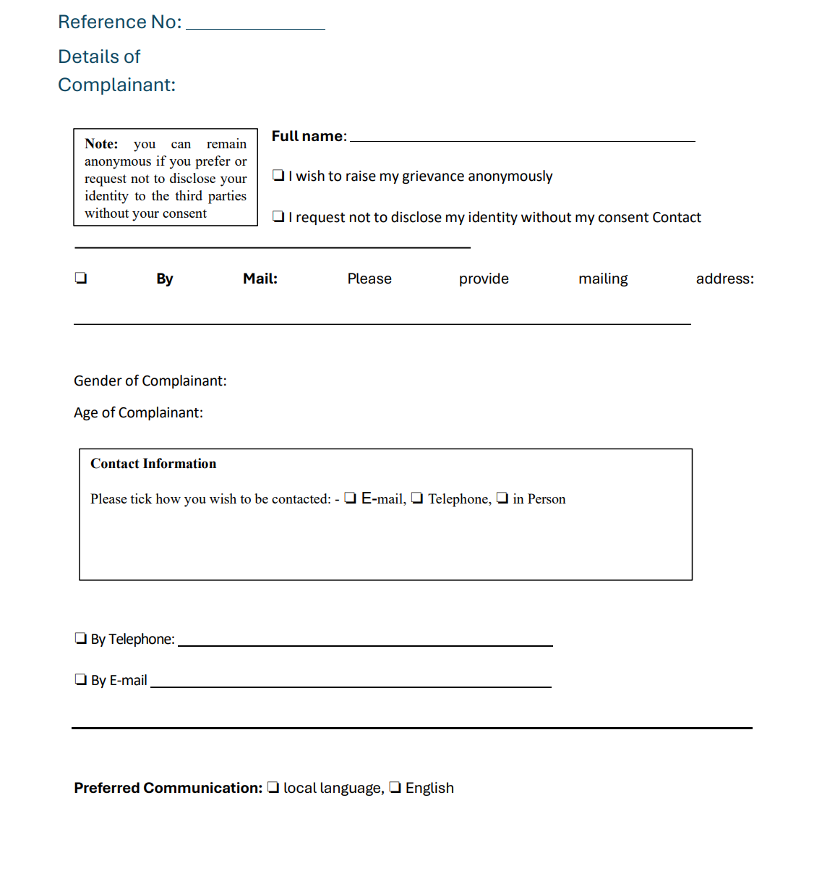
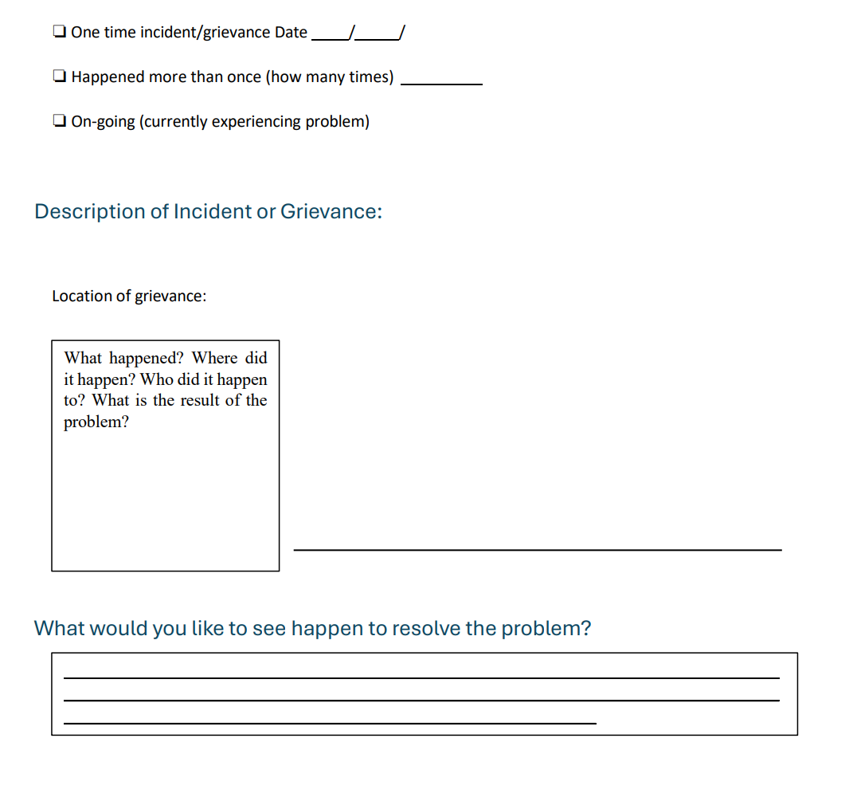

The grievance register will contain the following information (ideally in an excel file, or if at local level in a book):
Type of Information | Response
Complaint/ Log number
Reference document (s)
Date complaint made
Date complaint received
Category of Grievance
Method of Logging:
Complaint name (state if anonymous)
Location in which complained action took place
Caller contacts for follow up
Gender
Age
Parties against whom complaint is made (Unit/Agency, etc.)
Nature of Complaint ["SEA/GBV"; "Timing of Payment"; "Amount of Payment"; "Inclusion or Issue regarding Project benefits" or create standard categories based on complaint type]
Description of complaint
Nature of feedback (describe)[In case issue type is GBV/SEA immediate referral to the GBV referral system]
Verification and investigation (describe)
Recommended action (describe)
Timeline of Initial feedback (within 5 days) [investigate the claim within 5 working days, and share findings/feedback with relevant stakeholder]
Status update (and justification if it is not expected to be resolved within the timeframe set out)
Date Resolved
Indicate if a spot check has been conducted (you can include then in the narrative reports spot checks for resolutions of x number of complaints have been conducted)

